**Collapse/Expand All Group Boxes**

**Description**

This widget is used can be used to Expand and Collapse all the Group Boxes. This contains 2 Buttons Expand All and Collapse All which on clicking Expand and Collapses the Group boxes. The Widget is a Pluggable written in Custom Java Script Code. This Widget can be used to Expand and collapse two or more group boxes at once.

**Typical Usage Scenario**

Suppose your application needs to have the functionality like collapse or expand all the Group Boxes at once. In that case, this widget becomes a valuable tool. It allows you to incorporate the collapse and expand functionality seamlessly, enhancing the user experience when dealing with the two or more group boxes.

**Pre-Requisites**

NA

**Features and Limitations**

1. Feature - This Widget can be used to Expand and collapse two or more group boxes at once.
2. Limitation - Users can Just Download and place the widget wherever they want to Implement Expand and Collapse All for a Groupbox. This Widget can both Expand and Collapse all the Group Boxes. This Widget works only on the Groupbox.

**Dependencies**

1. Require Mendix 9 or above.

**Installation**

1. To import the component, click on App in the menu and select Show App Directory in Explorer.

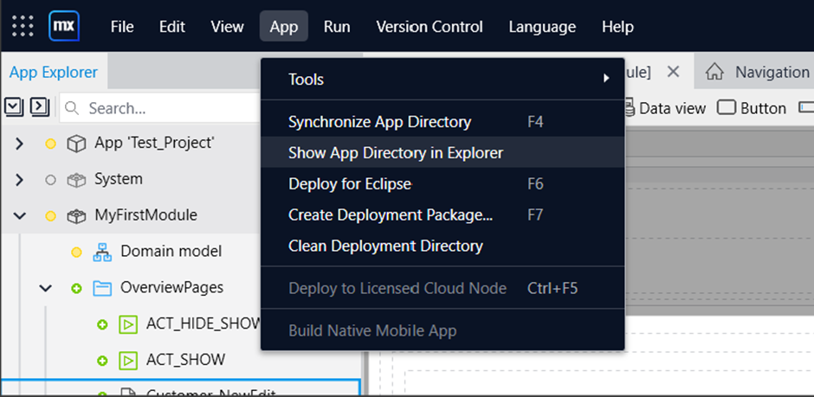

1. Open the Widgets folder in the app directory and place your Mendix package there.

1. Then, synchronize your App Directory on Mendix Platform by clicking on Synchronize App Directory under App in menu.

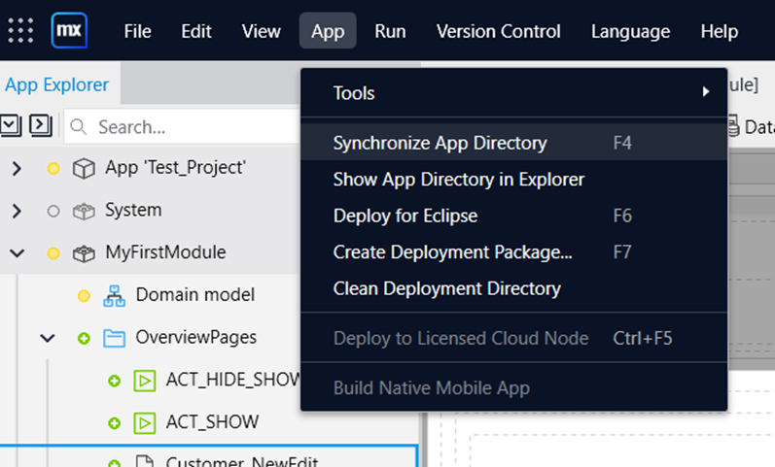

4. Once you Synchronize your app directory in mendix , you would be able to see your newly imported widget/component and then you can start using it.

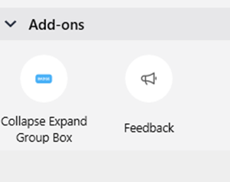

**Configuration: NA**

**Category: Module**

**Subcategory: All**

**Visibility: Public Marketplace**

**Studio Pro Version: 9.1.1**